## ClimateTrackSmart Using Blockchain

A Project report submitted in partial fulfillment of 7th semester indegree of BACHELOR OF ENGINEERING IN COMPUTER SCIENCE AND ENGINEERING

### Team ID: NM2023TMID03935

***Submitted by***

|  |  |
| --- | --- |
| JaasvBellshi Y | 950320104009 |
| Muthupradepa K | 950320104016 |
| RoselinMary | 950320104019 |
| SelvaLakshmi M | 950320104021 |
| Subhashine J | 950320104024 |



DEPARTMENT OF COMPUTER SCIENCE AND ENGINEERING

## GRACE COLLEGE OF ENGINEERING, THOOTHUKUDI

ANNA UNIVERSITY: CHENNAI 600025

### INTRODUCTION

* 1. Project Overview
  2. Purpose

### LITERATURESURVEY

* 1. Existing problem
  2. References
  3. Problem Statement Definition

### IDEATION&PROPOSEDSOLUTION

* 1. Empathy Map Canvas
  2. Ideation & Brainstorming

### REQUIREMENTANALYSIS

* 1. Functional requirement
  2. Non-Functional requirements

### PROJECTDESIGN

* 1. Data Flow Diagram & User Stories
  2. Solution Architecture

### PROJECT PLANNING & SCHEDULING

* 1. Technical Architecture
  2. Sprint Planning & Estimation
  3. Sprint Delivery Schedule

### CODING & SOLUTIONING (Explain the features added in the

**project along with code)**

* 1. Feature1
  2. Feature2
  3. Database Schema (if Applicable)

### PERFORMANCETESTING

* 1. Performance Metrics

### RESULTS

* 1. Output Screenshots

### ADVANTAGES&DISADVANTAGES

1. **CONCLUSION**

### FUTURESCOPE 13.APPENDIX

Source Code

GitHub & Project Demo Link

# 1.INTRODUCTION

* 1. **Project Overview:**

## ClimateTrackSmart Using Blockchain

The system monitors weather using temperature, humidity and rain sensors and provides live reports of weather statistics. Constantly monitor temperature with a temperature sensor,humidity with a humidity sensor, rain, etc.

**1.2 Purpose**

Having the right weather data can drive significant benefits: Predict upcoming storms: With a high-quality weather radar system, it can detect hazardous weather like tornadoes, hail or flooding as well as locate and calculate the speed of precipitation to support accurate arrival times.

**2. LITERATURE SURVEY**

**2.1 Existing problem**

The satellite weather reporting system provides the current condition that does not give the exact location condition.

**2.2References**

1. Andrews, ].W. 1993. Impact of weather event uncertainty upon an optimum ground-

holding strategy. Air-Traffic Control Quarterly 1(1): 59-8

2. Belair, 5., and LKaihot. 5001. lupact of horisontal resolution on Te aumerical Smuiston

of a midlatitude squall line: Implicit versus explicit condensation. Mon. Weather Rev.

129:2362-2376.

3. National Academies of Sciences, Engineering, and Medicine. 2003. Weather Forecasting

Accuracy for FAA Traffic Flow Management: A Workshop Report. Washington, DC: The

National Academies Press.

4. Beguin, D. and JL. Plante. 1998. Critical technology requested by fast scanning radar.

COST 75 Final International Seminar on Advanced Weather Radar Systems, Locarno,

Switzerland, 645- 657.

5. Benjamin, §.G., J.M.Brown, K Brundage, B.E.Schwartz, T.G. Smimova, and T.L Smith.

1998. The operational RUC-2. Preprints, 16th Conference on Weather Analysis and

Forecasting, Phoenix, AZ, American Meteorological Society, pp. 249-252.

6. Baldwin, M.P. and T.J.Dunkerton. 2001. Stratospheric harbingers of anomalous weather

regimes. Science 294:581-584.

7. Balsey, B.B., and K.5.Gage. 1980. The MST radar technique: Potential for middle

atmospheric studies. Pure and Applied Geophysics 118:452-493.

**2.3 Problem Statement Definition**

The satellite weather reporting system provides the current condition that does not give the exact location condition.

**3. IDEATION & PROPOSED SOLUTION**

**3.1 Empathy Map Canvas**

An empathy map is a collaborative tool teams can use to gain a deeper insight into their customers. Much like a user persona, an empathy map can represent a group of users, such as a customer segment. The empathy map was originally created by Dave Gray and has gained much popularity within the agile community.

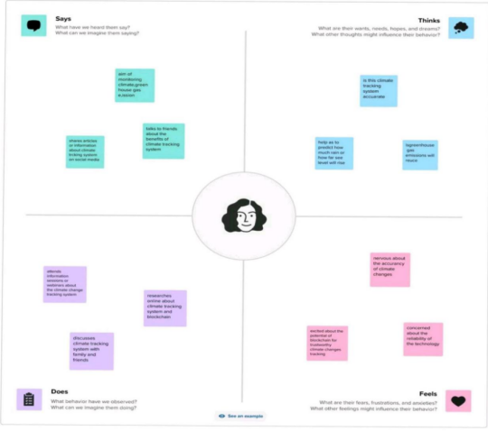

**3.2 Ideation and Brainstorming**

A group problem-solving technique that involves the spontaneous contribution of ideas from all members of the group.

**RULES**:

1.Lay out the problem you want to solve. ...

2.1dentify the objectives of a possible solution. ...

3.Try to generate solutions individually. ...

4.0nce you have gotten clear on your problems, your objectives and your personal

Solutions to the problems, work as a group.

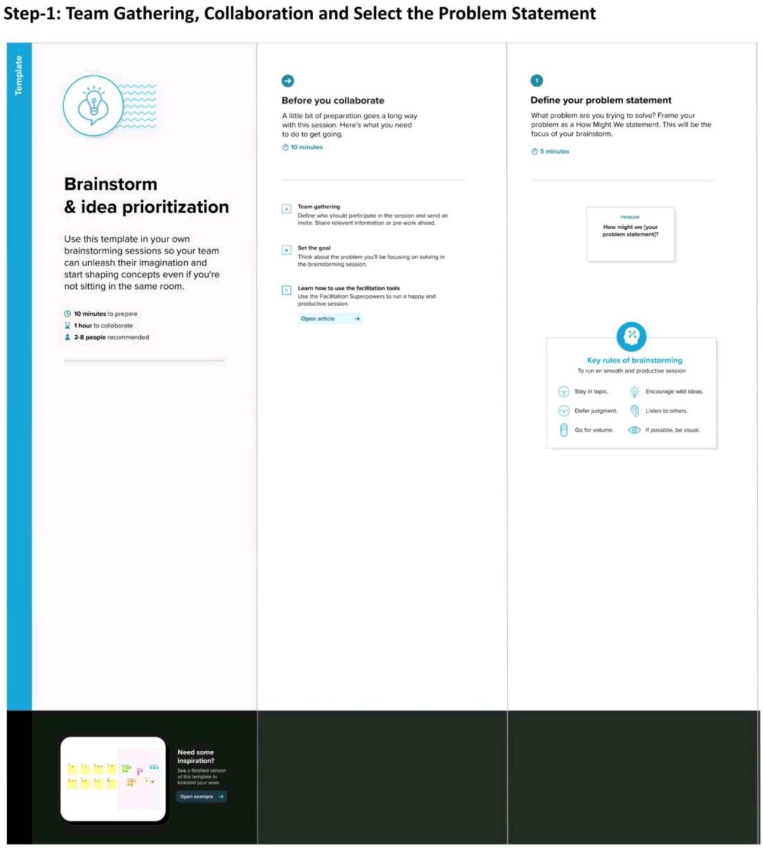

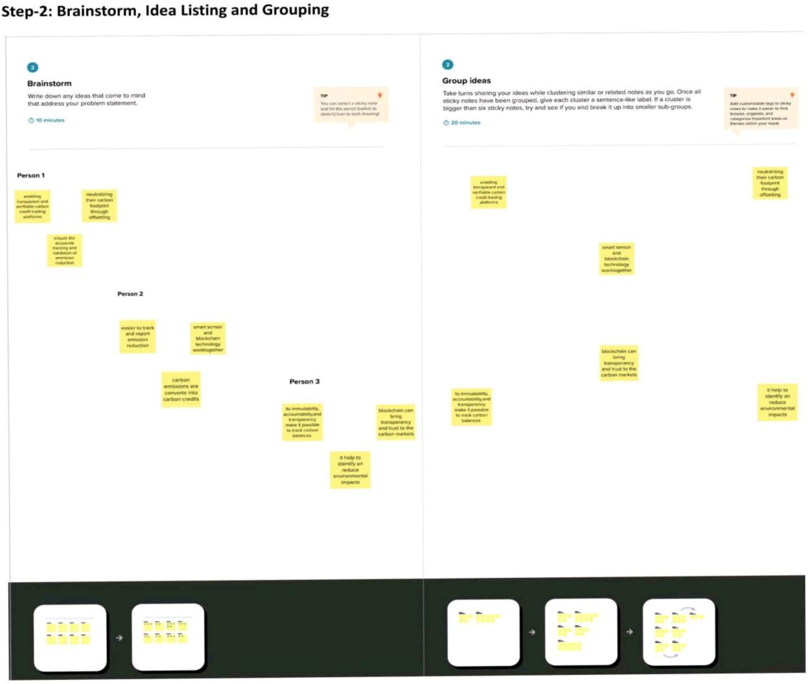

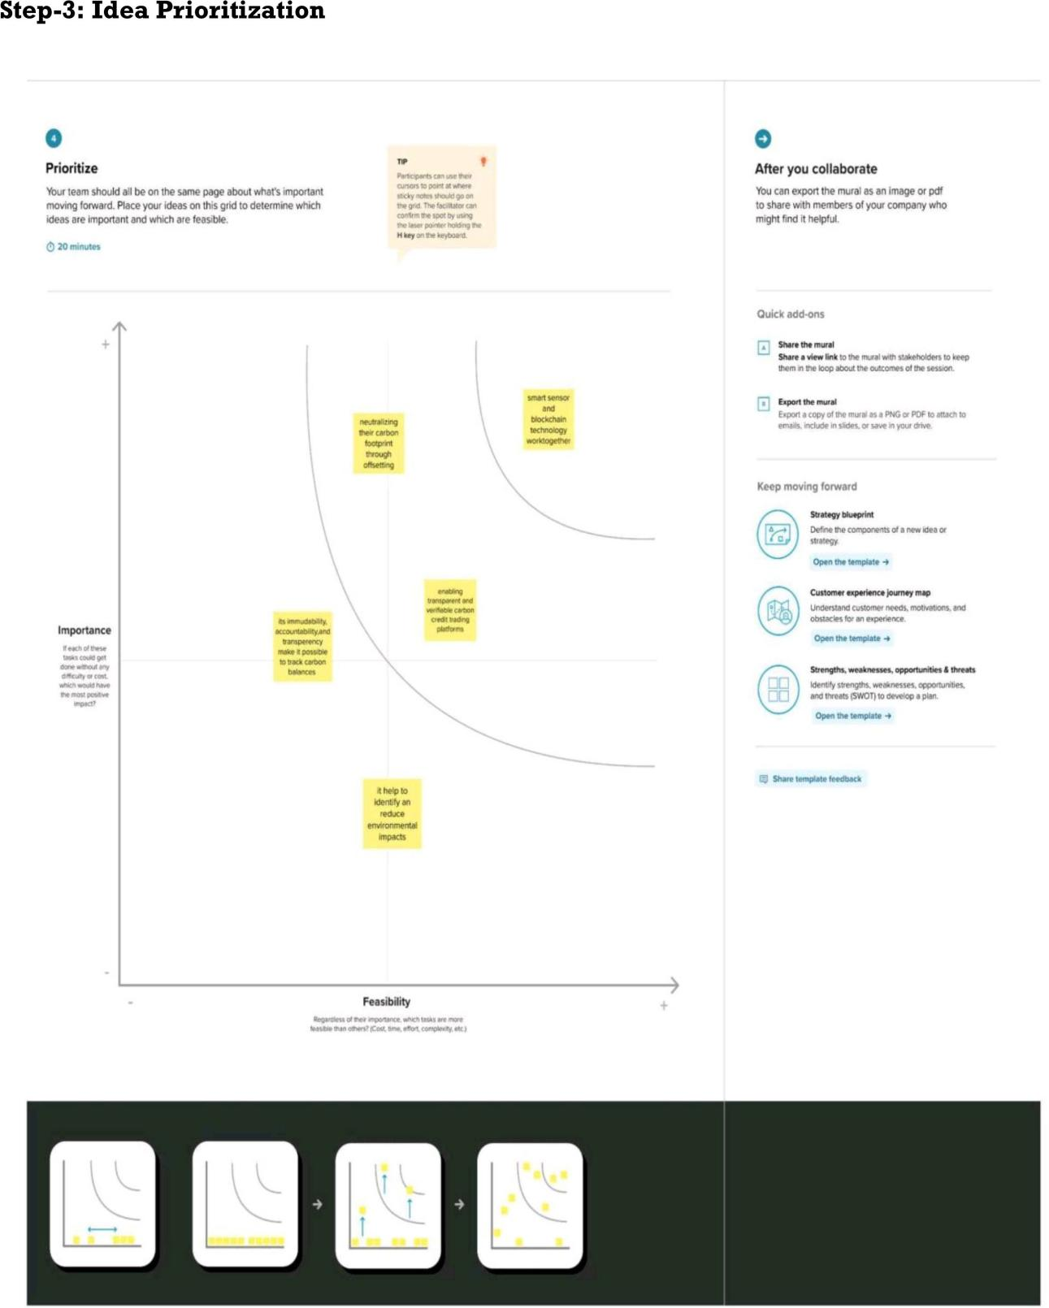

**4. REQUIREMENT ANALYSIS**

**4.1 Functional requirements**

The system shall be able to produce minimum, maximum and the average data of a particular weather parameter when it is requested by an operator.

The system shall provide the following weather parameters: temperature, pressure, wind speed & direction, rainfall, and humidity.

**4.2 Non-Functional requirements**

System's operational and location of remote station and central station shall not violate the current Government regulations of environment.

The weather sensors shall be able to be upgraded every 5 years.

**5.PROJECT DESIGN**

**5.1 Data Flow Diagrams & User Stories**

**Data flow diagram**

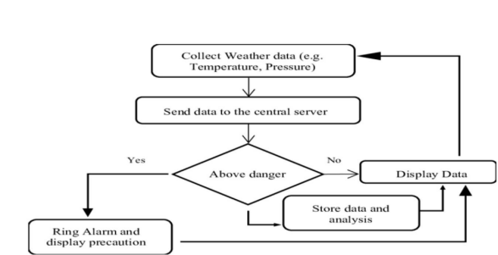

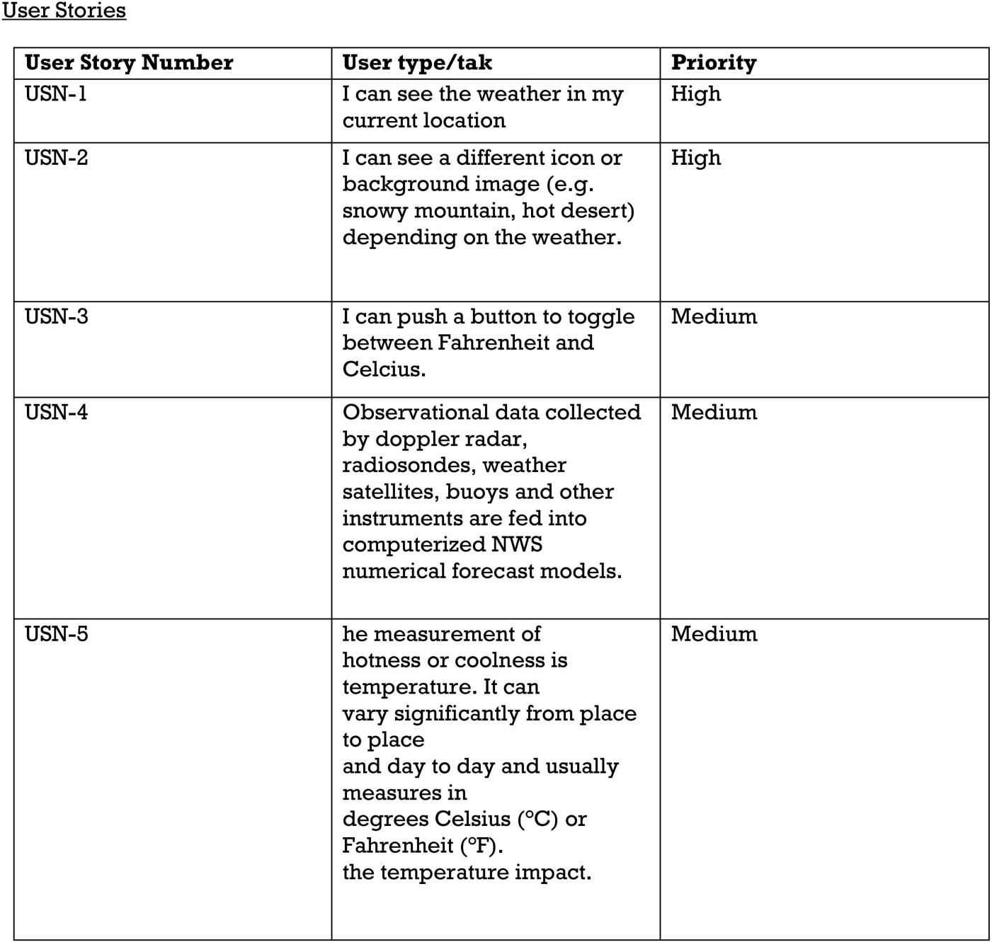

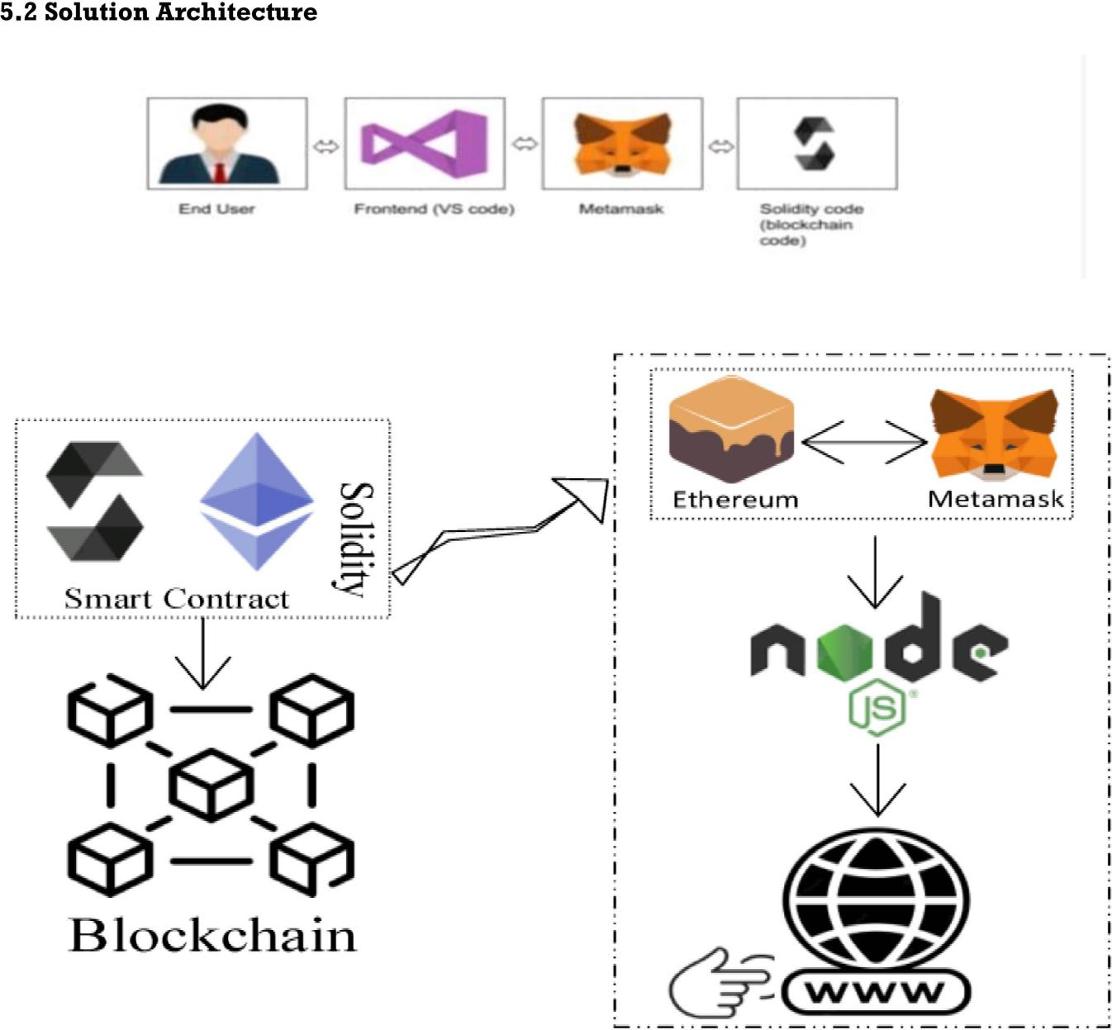

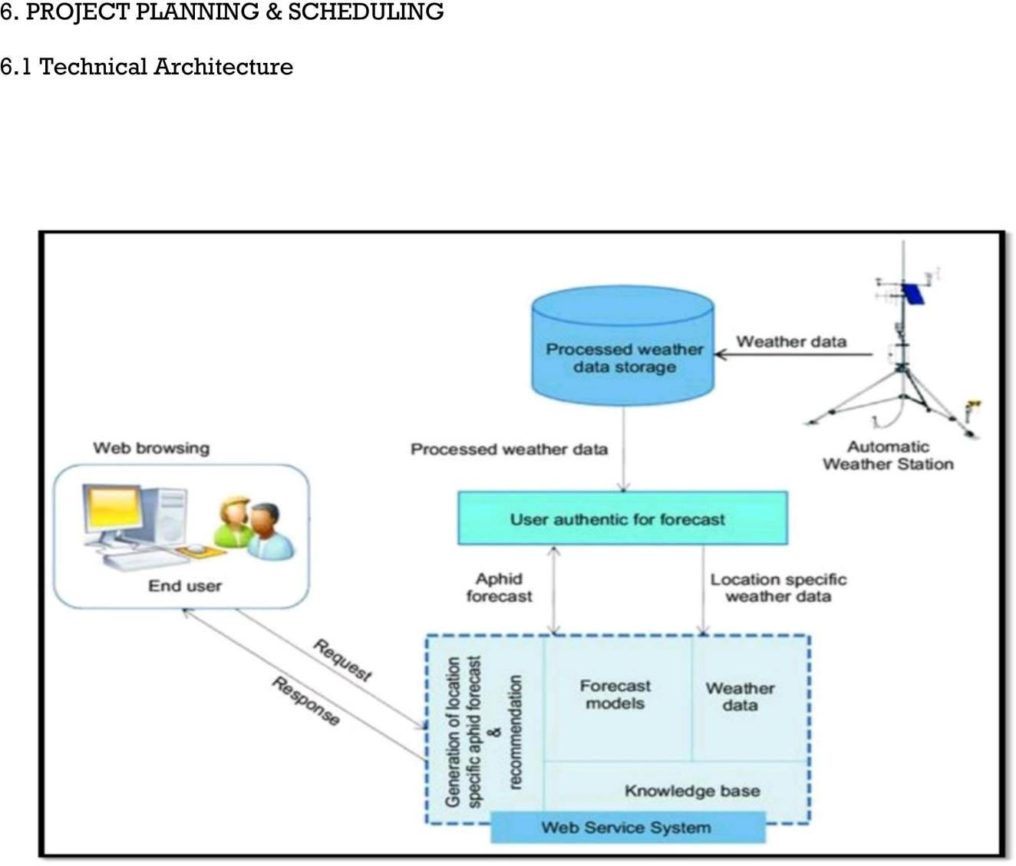

**Project Development Phase:**

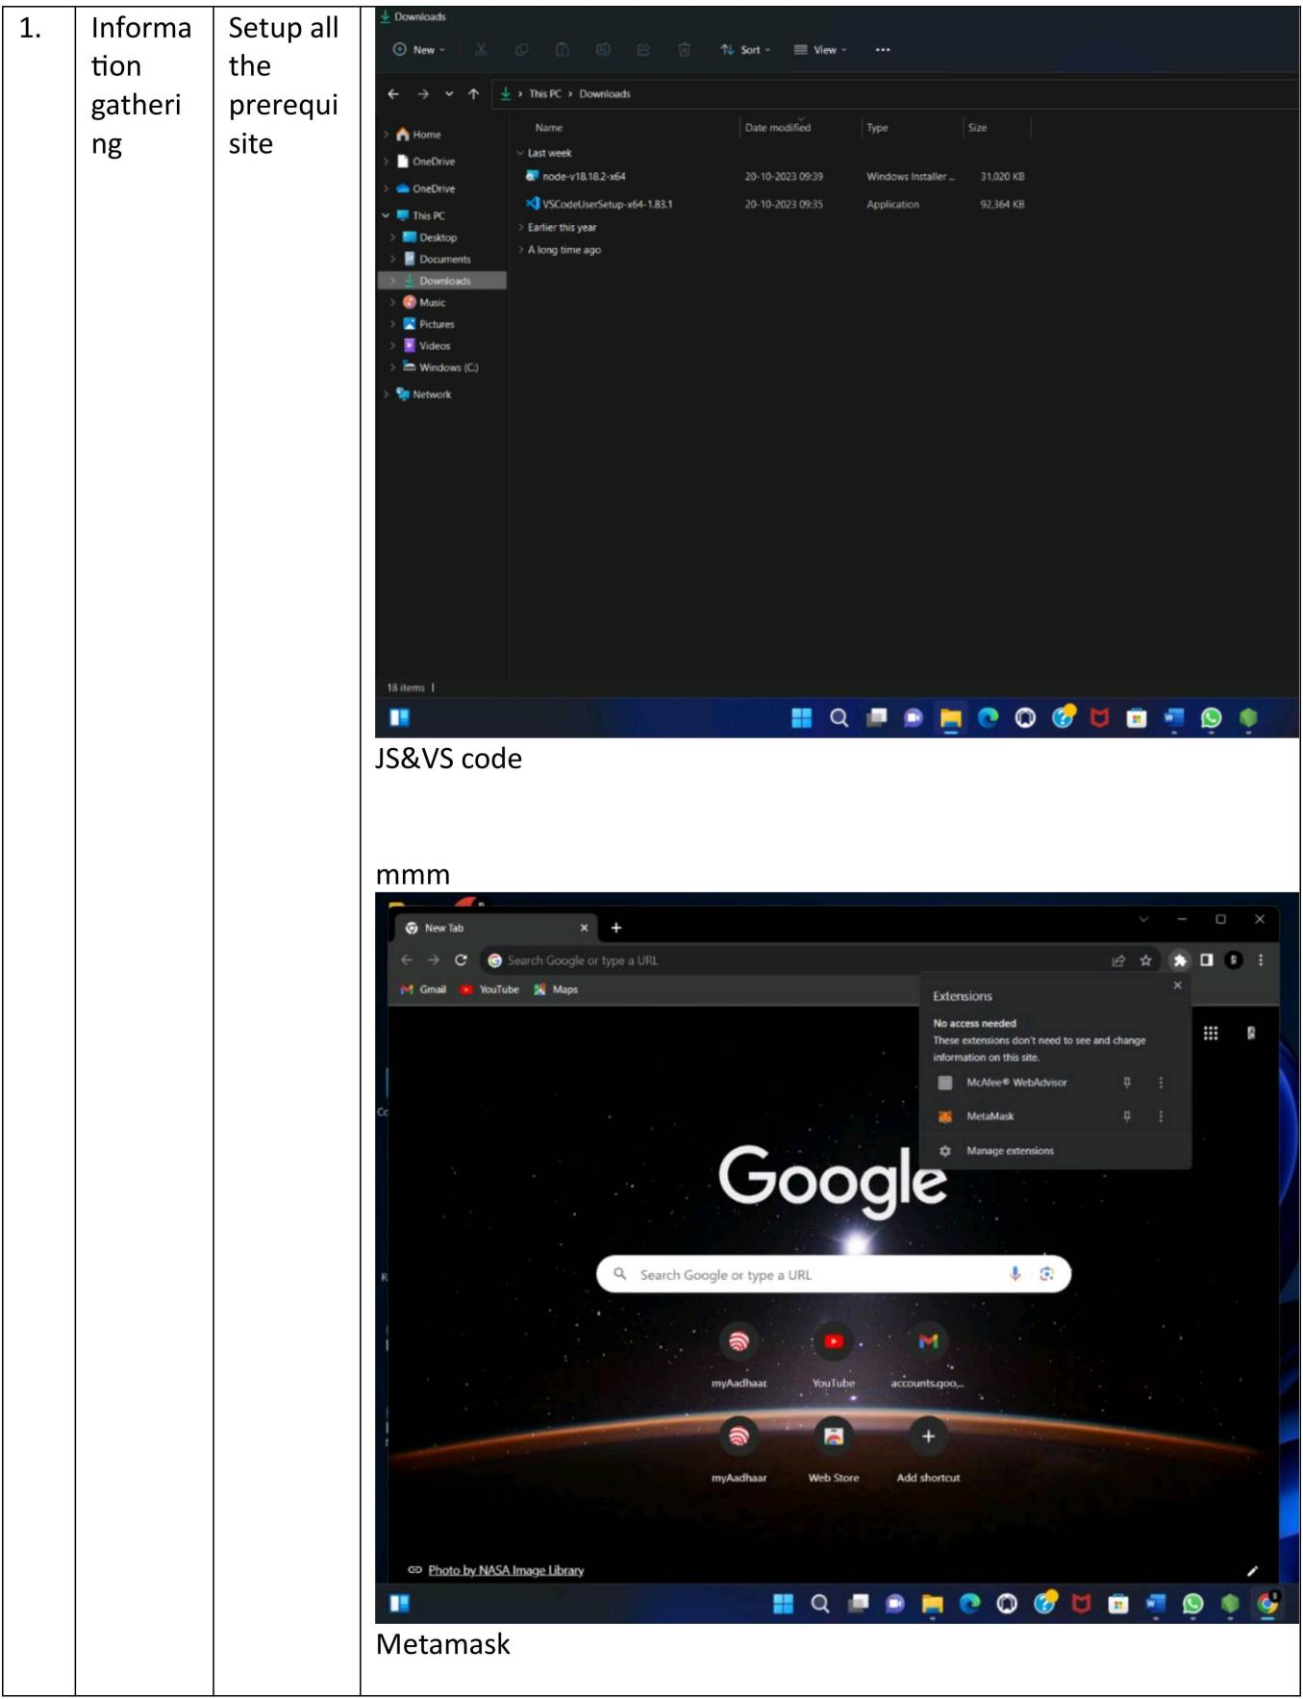

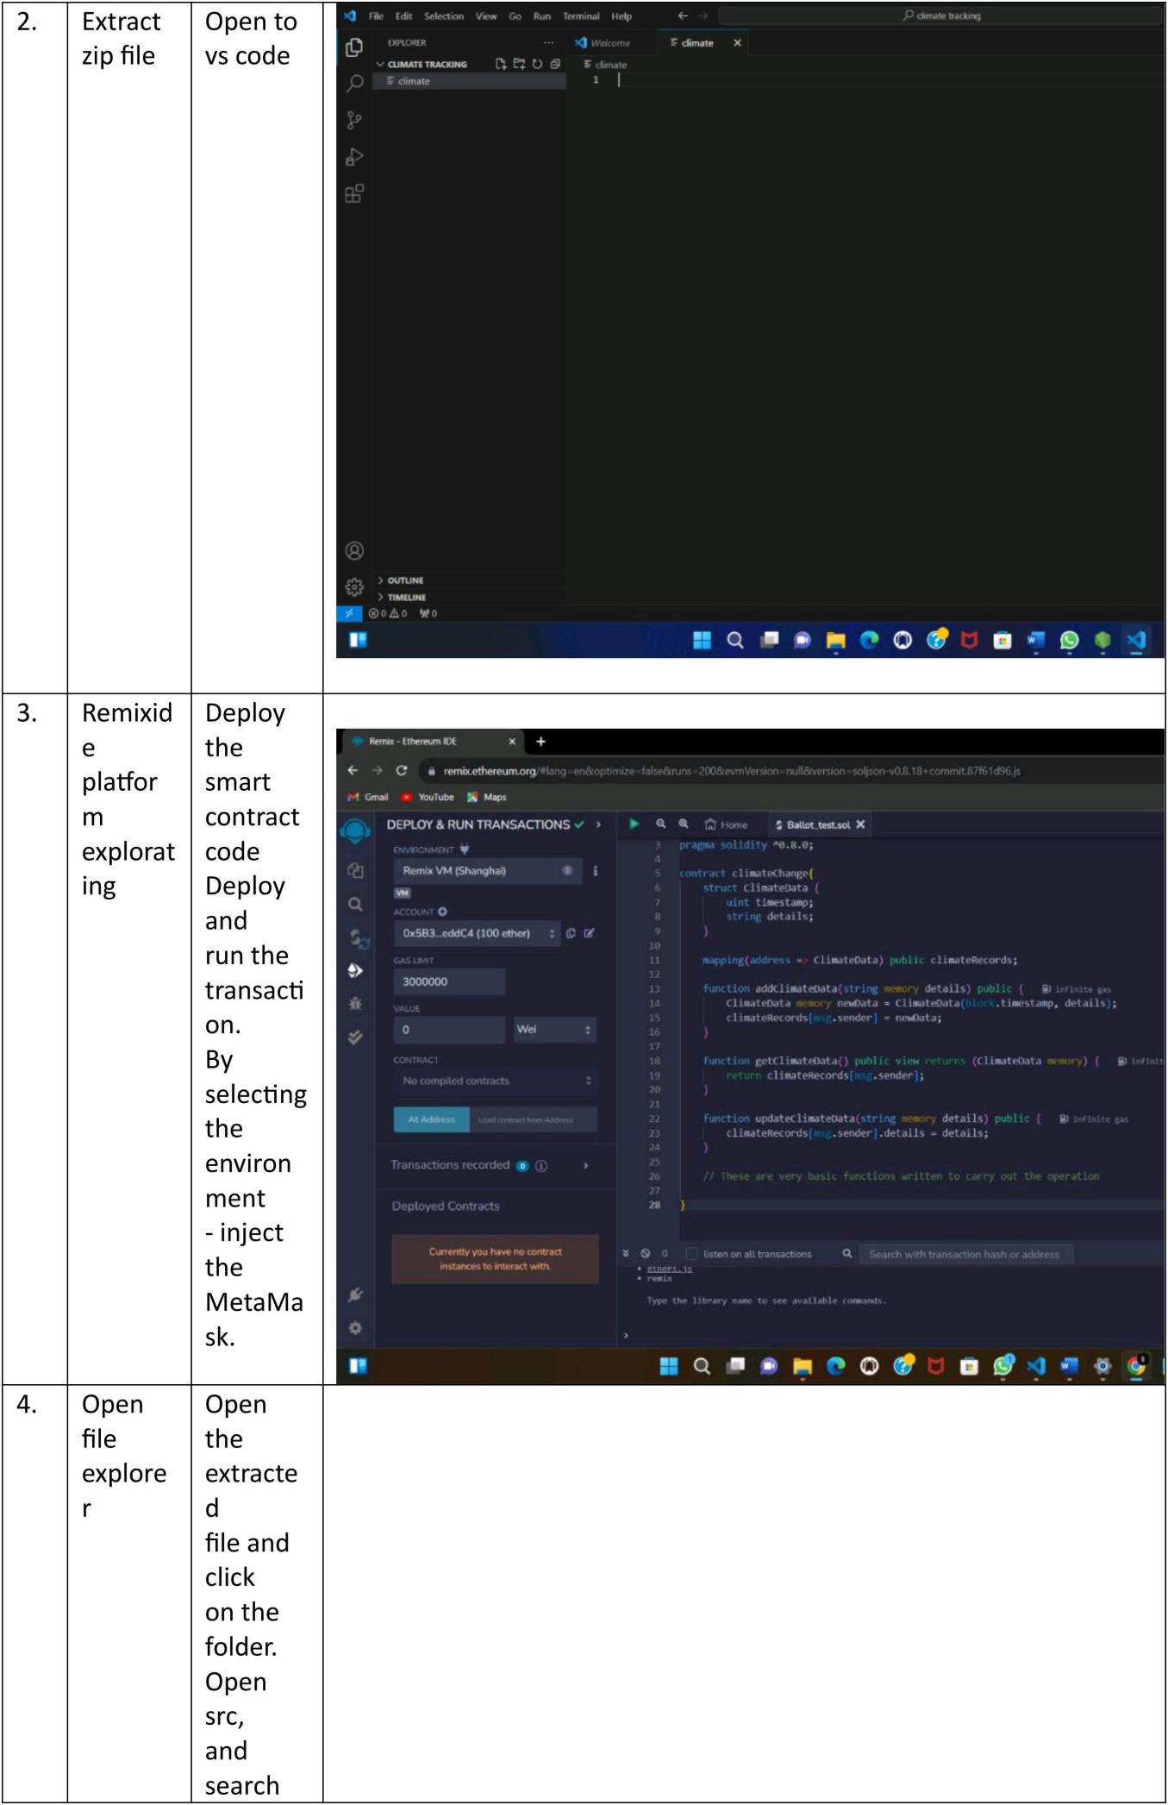

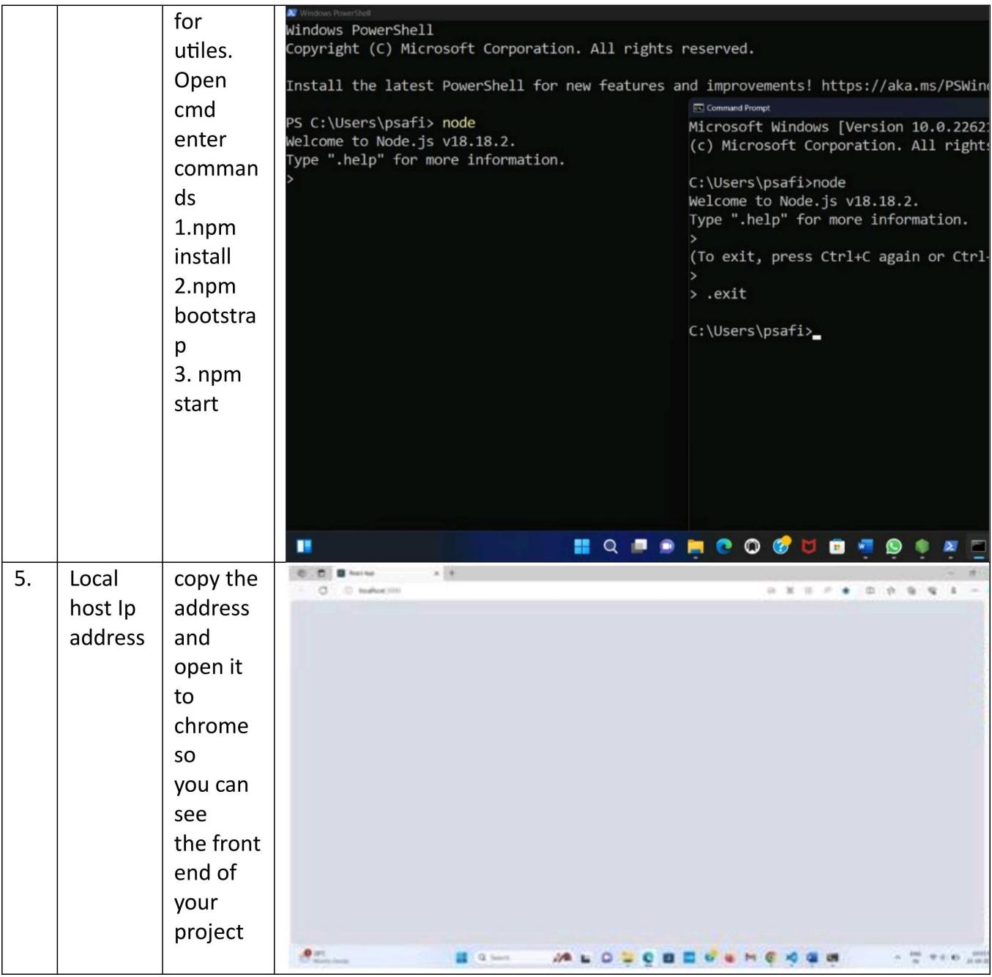

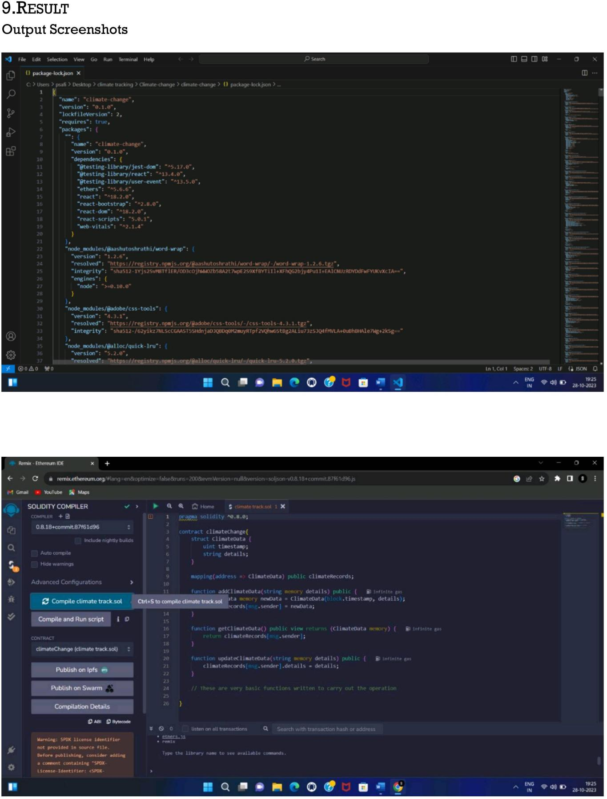

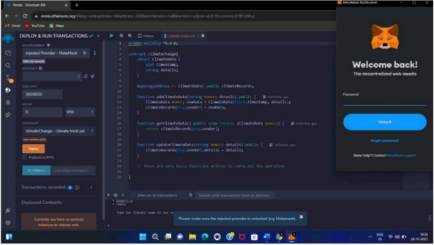

**10. ADVANTAGES & DISADVANTAGES**

**Advantages**

Blockchain and Web 3.0 can facilitate the collection and secured sharing of large amounts of environmental data, and allow researchers and institutions to collaborate on a global level.

Being able to forecast and plan for the future when it comes to the local climate.

**Disadvantages**

Cannot detect fog: Weather radar has the limitation of not being able to detect fog. This creates a gap in weather forecasting where an area that is likely to receive fog is not properly profiled.

The main disadvantage of an automatic weather station is that it removes the observer from the real elements being measured, and so the experience of what -5°C temperatures or 30 knot winds feel like, is lost.

1. **CONCLUSION**

Weather and climate are different, yet related concepts. One involves the atmospheric condition and current zone. The other involves the atmospheric condition of a larger area and for a more extended time.

**12. FUTURE SCOPE**

The future of weather applications is promising, with the increasing demand for real-time and accurate weather information. One potential development is the improvement in accuracy through the use of advanced data collection and analysis techniques, as well as sophisticated algorithms.

1. **APPENDIX**

**13.1Source code:**

pragma solidity ^0.8.0;

contract climateChange{

struct ClimateData {

}

uint timestamp;

string details;

mapping(address => ClimateData) public climateRecords;

function addClimateData(string memory details) public {

ClimateData memory newData = ClimateData(block.timestamp, details); climateRecords[msg.sender] = newData;

}

function getClimateData() public view returns (ClimateData memory) {

}

return climateRecords[msg.sender];

function updateClimateData(string memory details) public {

climateRecords[msg.sender].details = details:

}

{

"short_name": "React App",

"name": "Create React App Sample",

"icons": [

{

"src": "favicon.ico",

"sizes": "64x64 32x32 24x24 16x16",

"type": "image/x-icon"

},

{

"src": "logo192.png",

"type": "image/png",

"sizes": "192x192"

},

{

"src": "logo512.png",

"type": "image/png",

"sizes": "512x512"

}

],

"start_url": ".",

"display": "standalone",

"theme_color": "#000000",

"background_color": "#ffffff"

}

const { ethers } = require("ethers");

const abi = [

{

"inputs": [

{

"internalType": "string",

"name": "details",

"type": "string"

}

],

"name": "addClimateData",

"outputs": [],

"stateMutability": "nonpayable",

"type": "function"

},

{

"inputs": [

{

"internalType": "address",

"name": "",

"type": "address"

}

],

"name": "climateRecords",

"outputs": [

{

"internalType": "uint256",

"name": "timestamp",

"type": "uint256"

},

{

"internalType": "string",

"name": "details",

"type": "string"

}

],

"stateMutability": "view",

"type": "function"

},

{

"inputs": [],

"name": "getClimateData",

"outputs": [

{

"components": [

{

"internalType": "uint256",

"name": "timestamp",

"type": "uint256"

},

{

"internalType": "string",

"name": "details",

"type": "string"

}

],

"internalType": "struct climateChange.ClimateData",

"name": "",

"type": "tuple"

}

],

"stateMutability": "view",

"type": "function"

},

{

"inputs": [

{

"internalType": "string",

"name": "details",

"type": "string"

}

],

"name": "updateClimateData",

"outputs": [],

"stateMutability": "nonpayable",

"type": "function"

}

]

if (!window.ethereum) {

alert('Meta Mask Not Found')

window.open("https://metamask.io/download/")

}

export const provider = new ethers.providers.Web3Provider(window.ethereum);

export const signer = provider.getSigner();

export const address = "0x9Fd67609Bd692f21ac5eCC8e4CF07961f3587026"

export const contract = new ethers.Contract(address, abi, signer)

**13.2Github& Project Demolink:**

**Github link:**

**https://github.com/JaasvBellshi/ClimateTrackSmart-using-Blockchain**

**Demolink:**

**https://drive.google.com/file/d/1KBQoESeE8At1crcyKSGPyY3rUCm5LllA/view?usp=drivesdk**